LAB WORK 1
Cyber Threat Intelligence Report
  - Storm-2372 Device Code Phishing Campaign
MITRE ATT&CK Tactics and Techniques Mapping

Student: Shachar Levi
Student ID: 207688326
Course: Introduction to Information and Cyber Security

1. Executive Summary
This report analyzes Microsoft Threat Intelligence’s investigation of the Storm-2372 device code phishing campaign. Microsoft reported that the campaign had been active since August 2024 and targeted governments, NGOs, technology, defense, telecommunications, healthcare, higher education, and energy organizations across several regions. In July 2026, Microsoft updated its assessment and linked Storm-2372 to an initial-access operations sub-cluster of Midnight Blizzard.
The campaign abuses a legitimate OAuth device authorization flow rather than a software vulnerability. The actor builds trust, delivers a fake meeting invitation, convinces the victim to enter an attacker-generated device code on a legitimate Microsoft sign-in page, and thereby obtains valid access and refresh tokens. The stolen session is then used to search and exfiltrate email, register an actor-controlled device in some cases, and send additional internal phishing messages.

2. Source CTI Report
Publisher | Microsoft Threat Intelligence
Report | Storm-2372 conducts device code phishing campaign
Original publication | 13 February 2025; updated 31 July 2026
Source URL | https://www.microsoft.com/en-us/security/blog/2025/02/13/storm-2372-conducts-device-code-phishing-campaign/

3. Threat Actor and Targeting
Microsoft assesses that the activity aligns with Russian interests and tradecraft. The actor initially posed as a prominent person relevant to the target through services such as WhatsApp, Signal, or Microsoft Teams. The objective was espionage: obtaining persistent access to cloud accounts and collecting sensitive email and organizational information.

4. Attack Chain
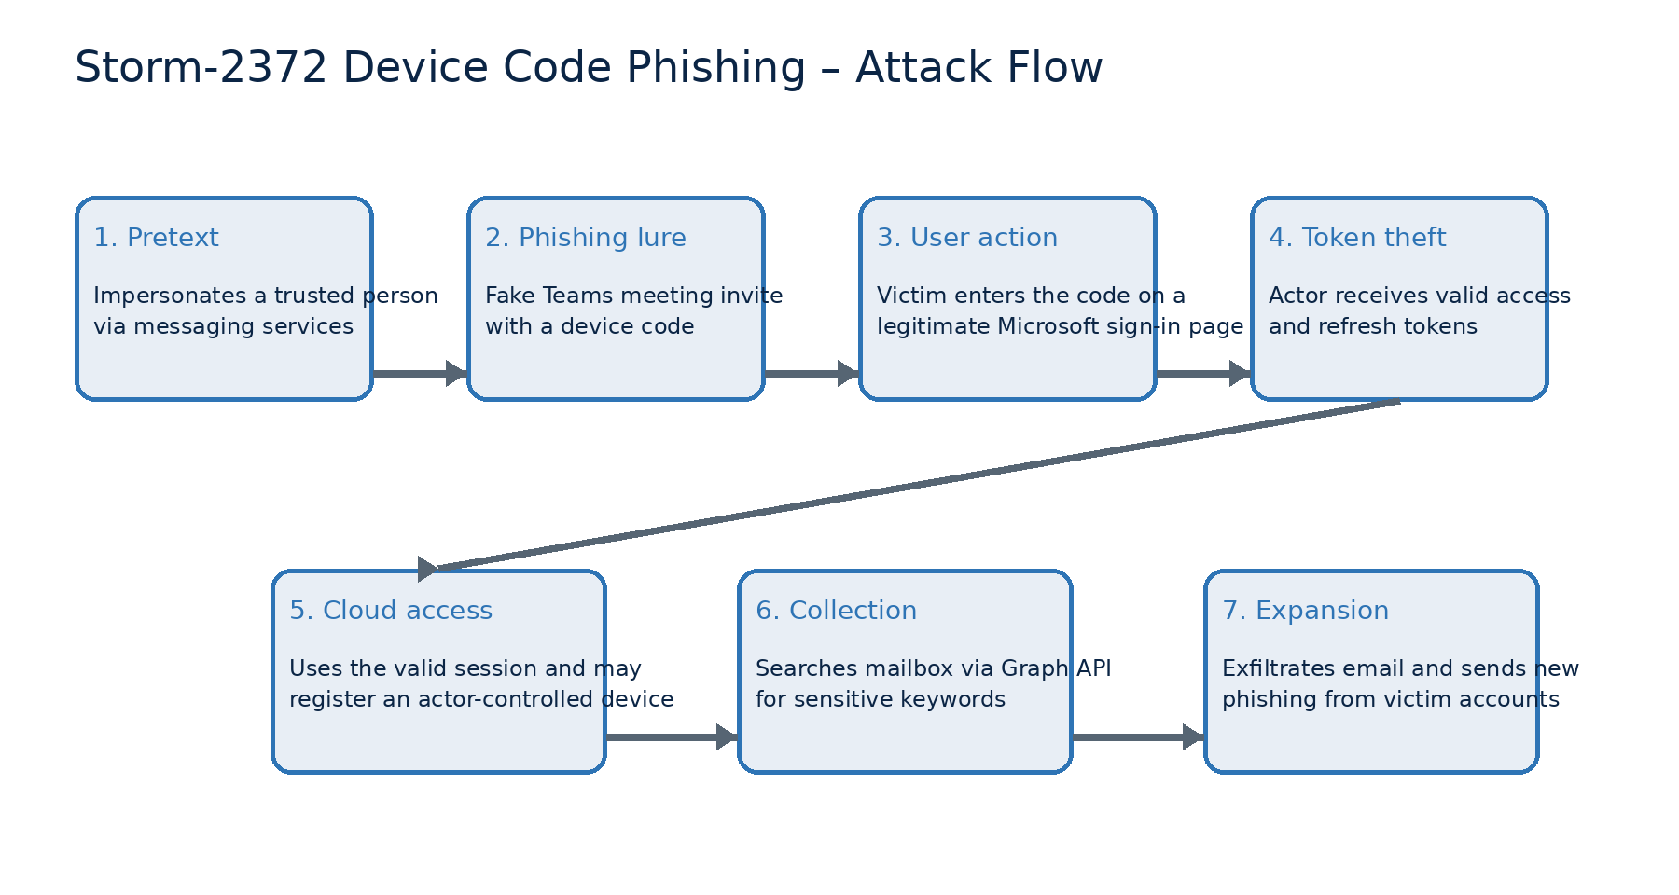
Figure 1. Analyst reconstruction of the device code phishing attack chain based on Microsoft Threat Intelligence reporting.

5. MITRE ATT&CK Mapping
The mapping below is an analyst assessment derived from the behaviors explicitly reported by Microsoft. It separates observed behavior from ATT&CK interpretation and avoids claiming techniques for which the source provides insufficient evidence.
Tactic | ID | Technique | Evidence and rationale | Confidence
Reconnaissance | T1589.003 | Gather Victim Identity Information: Employee Names | The actor researched relevant prominent people and approached selected targets under a trusted identity. | Medium
Initial Access | T1566.002 | Phishing: Spearphishing Link | Fake Teams meeting invitations directed targets into a device-code authentication flow. ATT&CK explicitly includes device-code phishing under this sub-technique. | High
Credential Access | T1528 | Steal Application Access Token | The victim’s authorization produced access and refresh tokens that became available to the actor. | High

5. MITRE ATT&CK Mapping (continued)
Tactic | ID | Technique | Evidence and rationale | Confidence
Defense Evasion / Persistence / Privilege Escalation / Initial Access | T1078.004 | Valid Accounts: Cloud Accounts | The stolen valid session was used to access Microsoft 365 resources as the compromised user. | High
Lateral Movement | T1534 | Internal Spearphishing | The actor sent additional device-code phishing messages from a compromised user’s account to other users in the organization. | High
Collection | T1114.002 | Email Collection: Remote Email Collection | Microsoft Graph was used to search mailboxes and collect email remotely. | High
Command and Control | T1090 | Proxy | Regionally appropriate proxies were used to conceal suspicious sign-in activity. | High

6. Observable Behaviors and Indicators
This campaign is behavior-rich but does not rely on a stable attacker-owned infrastructure set. Useful detection signals include device-code sign-ins followed by token use from unusual networks, close-in-time device registration, anomalous refresh-token or Primary Refresh Token activity, mailbox searches through Microsoft Graph, and phishing messages sent from a newly compromised internal account.
Investigators should also examine sign-in geography, proxy or ASN changes, application/client identifiers, audit records for device enrollment, Microsoft Graph access to Exchange data, and rapid expansion from one compromised user to additional recipients.

7. Risk and Impact
The attack can bypass the practical protection expected from passwords and conventional MFA because the victim completes a legitimate authentication flow. A successful compromise may expose sensitive email, cloud files, contacts, organizational relationships, and credentials stored in messages. Internal messages from a legitimate account also increase the credibility of follow-on phishing and can expand the compromise.

8. Recommended Defensive Measures
- Block the OAuth device code flow where it is not operationally required; otherwise restrict it through Conditional Access.
- Revoke refresh tokens and force re-authentication immediately after suspected device-code phishing.
- Use phishing-resistant authentication such as FIDO2 security keys or passkeys.
- Restrict which users may enroll devices in Microsoft Entra ID and monitor new device registrations.
- Monitor Microsoft Graph and Exchange activity for unusual mailbox searches, high-volume access, or access following token anomalies.
- Train users to verify meeting invitations and never enter a device code supplied by an unsolicited contact.
- Alert on internal phishing patterns and risky sign-ins, including regionally inconsistent proxy or ASN activity.

9. Conclusion
Storm-2372 demonstrates how an adversary can turn a legitimate identity protocol into an effective espionage path. The decisive security events occur in the identity and cloud control plane: social engineering leads to token theft, valid cloud access, mailbox collection, and internal expansion. The most important controls are reducing device-code-flow exposure, enforcing phishing-resistant authentication, restricting device enrollment, and correlating identity, device, email, and Graph API telemetry.

10. References
- Microsoft Threat Intelligence, “Storm-2372 conducts device code phishing campaign.” https://www.microsoft.com/en-us/security/blog/2025/02/13/storm-2372-conducts-device-code-phishing-campaign/
- MITRE ATT&CK – T1566.002 Spearphishing Link. https://attack.mitre.org/techniques/T1566/002/
- MITRE ATT&CK – T1528 Steal Application Access Token. https://attack.mitre.org/techniques/T1528/
- MITRE ATT&CK – T1078.004 Cloud Accounts. https://attack.mitre.org/techniques/T1078/004/
- MITRE ATT&CK – T1534 Internal Spearphishing. https://attack.mitre.org/techniques/T1534/
- MITRE ATT&CK – T1114.002 Remote Email Collection. https://attack.mitre.org/techniques/T1114/002/
- MITRE ATT&CK – T1090 Proxy. https://attack.mitre.org/techniques/T1090/
- MITRE ATT&CK – T1589.003 Employee Names. https://attack.mitre.org/techniques/T1589/003/

